Learn how to greet using British Sign Language (BSL)

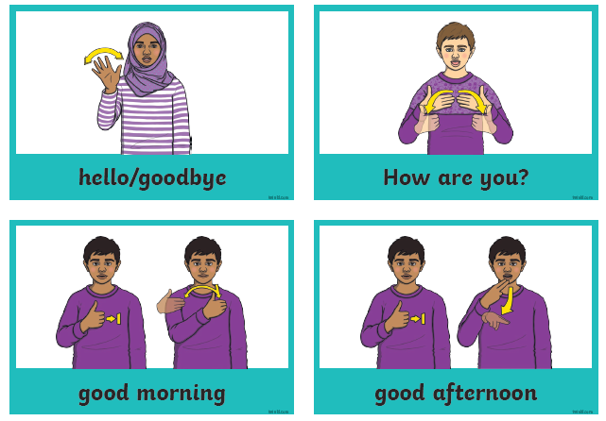
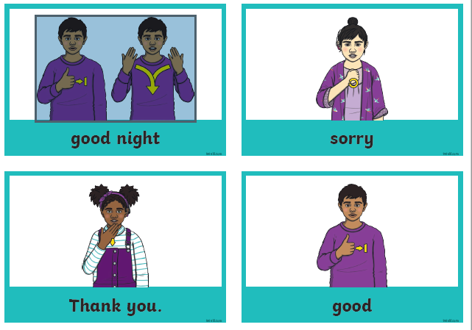
Dysgu sut i gyfarch gan ddefnyddio Iaith Arwyddion Prydain (BSL)
Colour in the mindfulness colouring sheets – see the attached link

Lliwiwch y taflenni lliwio ymwybyddiaeth ofalgar - gweler y ddolen atodedig
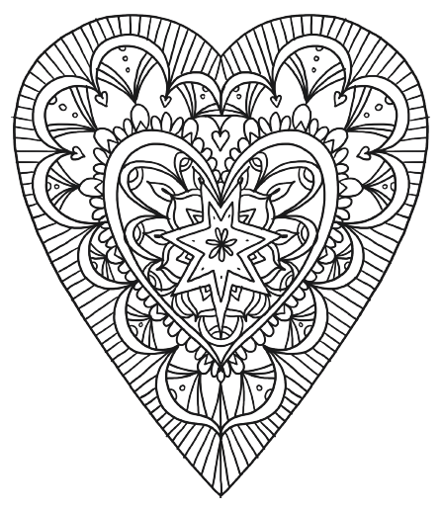

Complete the Easter dot to dots to reveal the Easter picture. Once complete, colour in

Cwblhewch y dot Pasg i ddotiau i ddatgelu llun y Pasg. Ar ôl ei gwblhau, lliwiwch i mewn

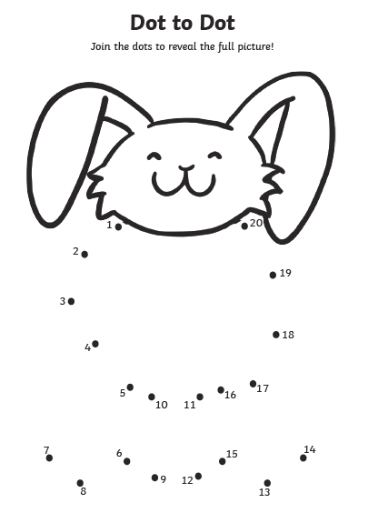
Complete the farm animal Sudoku – see the attached link

Cwblhewch yr ‘Sudoku’ anifeiliaid fferm - gweler y ddolen atodedig

https://content.twinkl.co.uk/resource/55/79/T-T-15617-Farm-Animal-Sudoku.pdf?__token__=exp=1585740860~acl=%2Fresource%2F55%2F79%2FT-T-15617-Farm-Animal-Sudoku.pdf%2A~hmac=216db9753fb05e65477f0b071935562ae2fe1daa3d3f52945cbd8e5352d63be9
Bake some easter biscuits
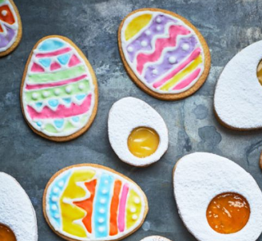
Ingredients for the biscuits:
300g plain flour, plus extra for dusting
150g white caster sugar
150g slightly salted butter, chopped
1 large egg
2 tsp vanilla extract or vanilla bean paste

Ingredients for the icing:
500g royal icing sugar
your favourite food colouring gels

Weigh the flour and sugar in a bowl. Add the butter and rub together with your fingertips until the mixture resembles wet sand, with no buttery lumps. Beat the egg with the vanilla, then add to the bowl. Mix briefly with a cutlery knife to combine, then use your hands to knead the dough together – try not to overwork the dough, or the biscuits will be tough. Shape into a disc, then wrap in cling film and chill for at least 15 mins. Heat oven to 180C/160C fan/gas 4. Line two baking sheets with baking parchment.
Dust a work surface with flour. Roll out to the thickness of a £1 coin. Use an egg-shaped cookie cutter (ours was 10cm long; you could also make a cardboard template to cut around) to stamp out as many cookies as you can, then transfer them to one of the baking sheets, leaving a little space between the biscuits.
Bake for 12-15 mins, until the biscuits are pale gold. Cool on the sheets for 10 mins, then transfer to a wire rack to cool fully. Once cool, decorate to your liking (see next steps).
To decorate the biscuits with icing, add enough water to the icing sugar to make a thick icing – it should hold its shape without spreading when piped. Transfer about a third of the icing to a piping bag fitted with a very small round nozzle (or just snip a tiny opening at the tip). Pipe an outline around the biscuits, then draw patterns in the middle – lines, spots and zigzags work well. Leave to dry for 10 mins. Divide the remaining icing between as many colours as you’d like to use, then use the gels to dye them. Loosen each icing with a few drops of water, then transfer them to piping bags. Use the coloured icing to fill the empty spaces on the biscuits. You may need to use a cocktail stick to tease it into the corners. Once covered, leave to dry for a few hours.
Will keep in an airtight container for up to five days.

Pobi bisgedi pasg

Cynhwysion ar gyfer biscedi:
300g o flawd plaen, ac bach yn ychwanegol i wasgaru
150g siwgr mân
150g menyn wedi'i halltu, wedi'i dorri
1 wy mawr
2 lwy de o fanila neu past ffa fanila

Cynhwysion ar gyfer yr eisin:
500g siwgr eisin brenhinol
eich hoff lliw bwyd

Pwyswch y blawd a'r siwgr mewn powlen. Ychwanegwch y menyn a'i rwbio ynghyd â blaenau eich bysedd nes bod y gymysgedd yn debyg i dywod gwlyb, heb lympiau. Curwch yr wy gyda'r fanila, yna ychwanegwch at y bowlen. Cymysgwch i gyfuno, yna defnyddiwch eich dwylo i dylino'r toes gyda'i gilydd - ceisiwch beidio â gorweithio'r toes, neu bydd y bisgedi'n galed. Siâpiwch i mewn i bel, yna lapio cling film a'i oeri am o leiaf 15 munud. Cynheswch y popty i nwy 180C / 160C 4. Leiniwch ddwy hambwrdd pobi gyda papur pobi.
Llwchwch yr arwyneb gwaith gyda blawd. Rholiwch allan y toes i drwch darn arian £1. Defnyddiwch dorrwr cwci siâp wy (roedd ein un ni yn 10cm o hyd; fe allech chi hefyd wneud templed cardbord i dorri o gwmpas) a torrwch cymaint o gwcis ag y gallwch, yna eu trosglwyddo i’r papur pobi, gan adael ychydig o le rhwng y bisgedi.
Pobwch am 12-15 munud, nes bod y bisgedi yn lliw aur gwelw. Oerwch y bisgedi am 10 munud, yna eu trosglwyddo i rac weiren i oeri’n llawn. Ar ôl iddynt oeri, addurnwch (gweler y camau nesaf isod i wneud eisin lliw).
I addurno'r bisgedi gydag eisin, ychwanegwch ddigon o ddŵr i'r siwgr eisin i wneud eisin trwchus - dylai ddal ei siâp heb ymledu wrth ei beipio. Trosglwyddwch yr eisin i fag pibellu gyda ffroenell crwn fach (neu torrwch pen off y bag pibellu). Gwnewch amlinelliad o amgylch y bisgedi gyda’e eisin, yna lluniwch batrymau yn y canol - mae llinellau, smotiau a patrymau igam-ogam yn gweithio'n dda. Gadewch i sychu am 10 munud. Rhannwch yr eisin sy'n weddill rhwng cymaint o liwiau ag yr hoffech chi eu defnyddio. Llaciwch bob eisin gydag ychydig ddiferion o ddŵr, yna trosglwyddwch nhw i fagiau pibellau. Defnyddiwch yr eisin lliw i lenwi'r lleoedd gwag ar y bisgedi. Efallai y bydd angen i chi ddefnyddio ffon coctel i'w phryfocio i'r corneli. Ar ôl ei orchuddio, gadewch i sychu am ychydig oriau.
Maen’t yn cadw mewn cynhwysydd aerglos am hyd at bum niwrnod.

Emoji Code Breaking

Torri Cod Emoji

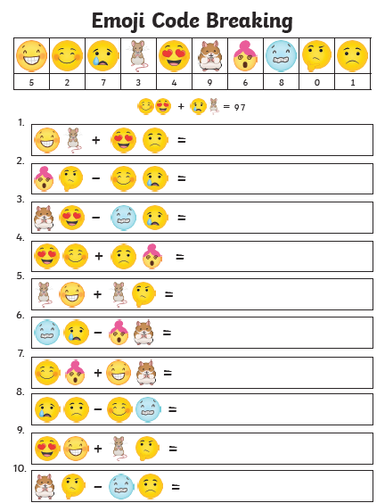

Do a workout

Sesiwn ymarfer corff
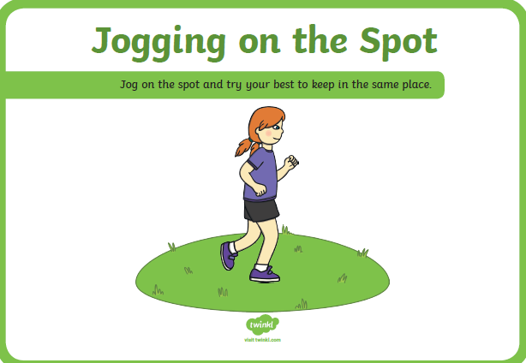
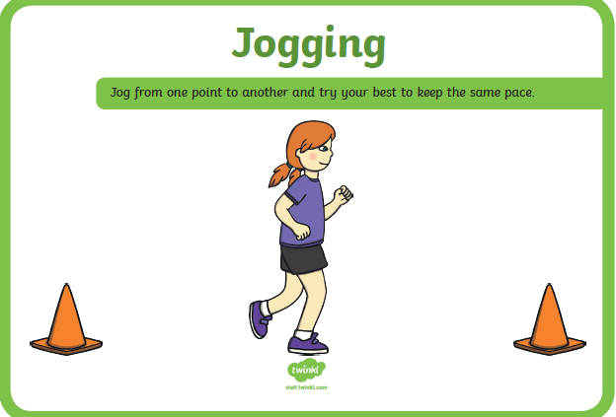

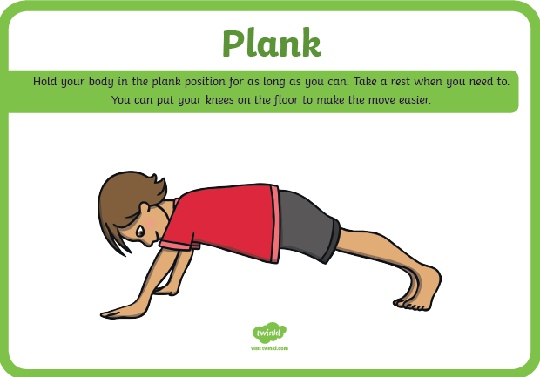
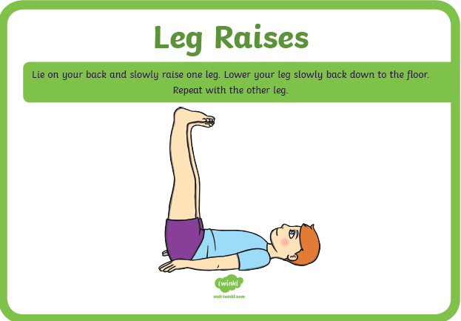

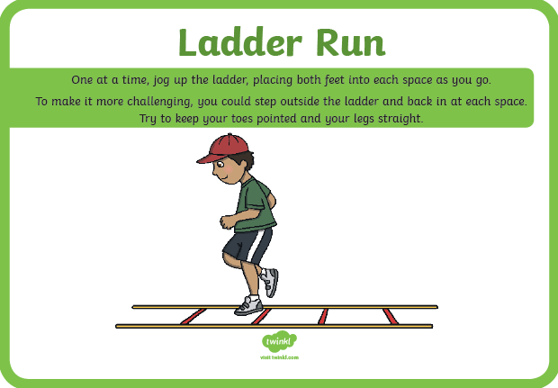
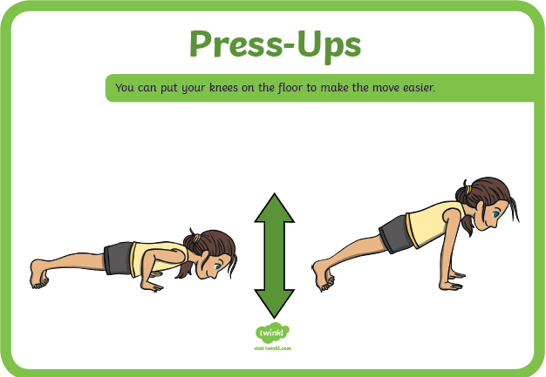

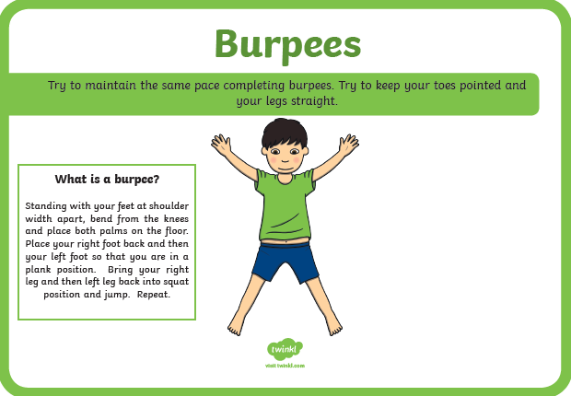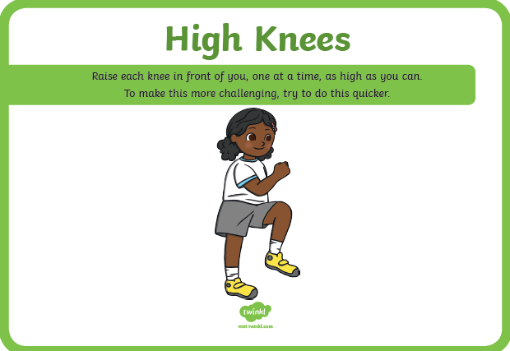

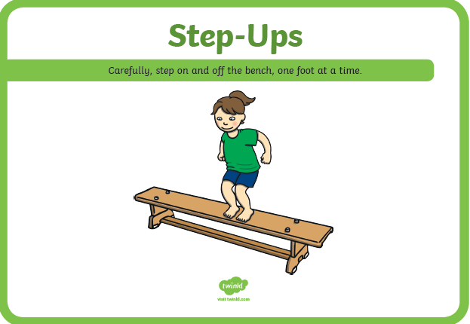

Write what you have done today, and add or draw a picture in the box

Ysgrifennwch yr hyn rydych chi wedi'i wneud heddiw, ac ychwanegu neu tynwch llun yn y blwch
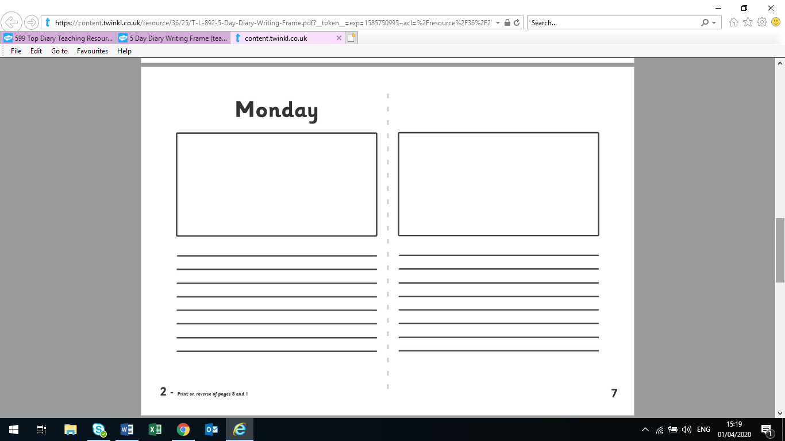
Paint and decorate a stone

Paentio ac addurno carreg

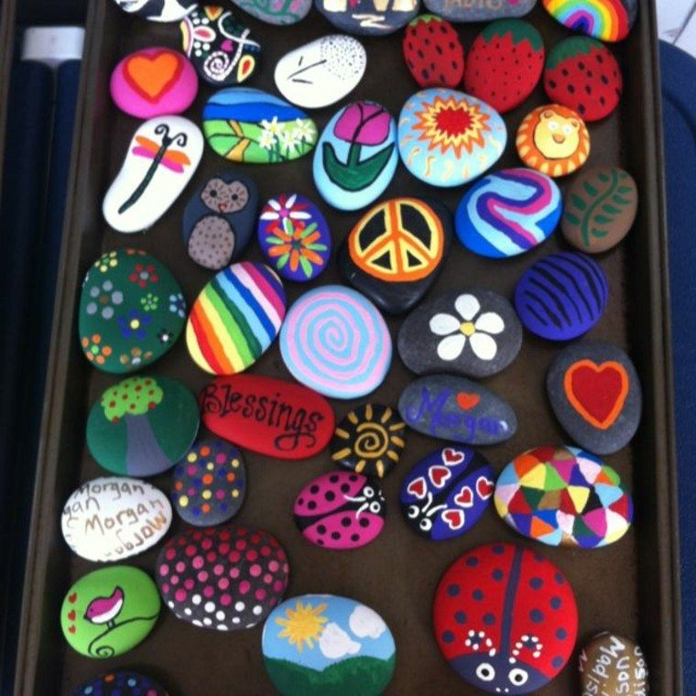
Do a chore at home – wash the dishes

Gwnewch dasg gartref - golchwch y llestri

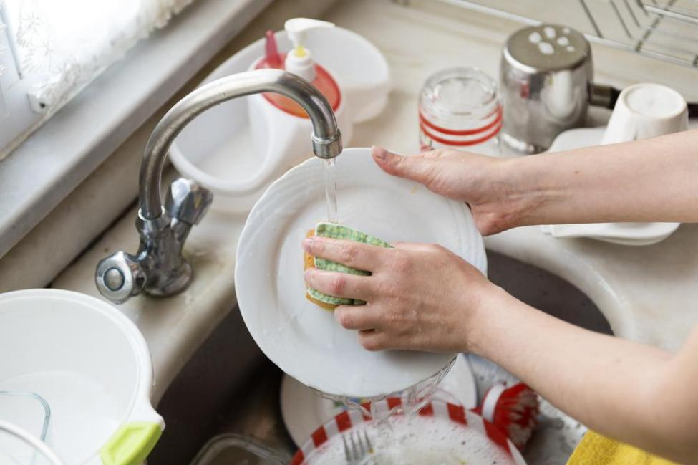

Make homemade play dough to play with

Gwneud toes chwarae

