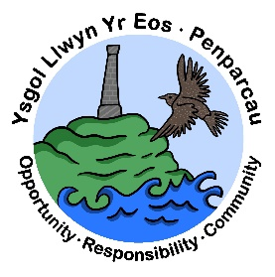 | CYNGOR SIR CEREDIGION COUNTY COUNCIL  Ysgol Gymunedol Llwyn yr Eos Community School  Penparcau  ABERYSTWYTH  Ceredigion  SY23 1SH
Prifathro/Headteacher  Mr Brian A L Evans | Ffôn/Phone 01970 617011  01970 625809  E-mail b.evans3@llwyn-yr-eos.ceredigion.sch.uk

Newsletter – May 2022

Dear Parents/Guardians,

The school council have decided to create a monthly newsletter for our parents, guardians and local community. We will share some good news, dates and other information for you in our newsletter. There will also be a section from our ‘Criw Cymraeg’ – our Welsh Crew who are responsible for developing Welsh as a second language for our pupils in the school.

The Great Outdoors

It has been a busy start to the new term. We have decided on a whole school theme for this half term - ‘The Great Outdoors’. The children have been busy exploring the outdoors of Penaprcau and Aberystwyth and have been producing excellent work.
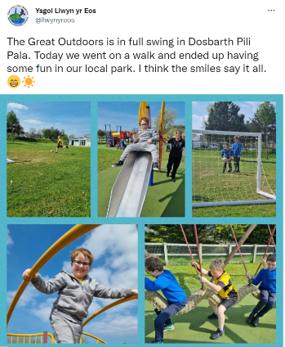
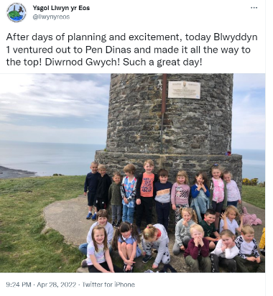
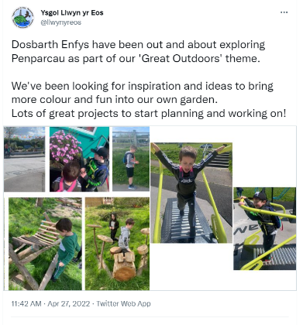

If would like to see more examples of what the children have been getting up to, you can visit our twitter page for more pictures and videos - @llwynyreos

Half Term Holidays

The school will close on Friday, May 27th and reopen on Monday 6th June.

Football

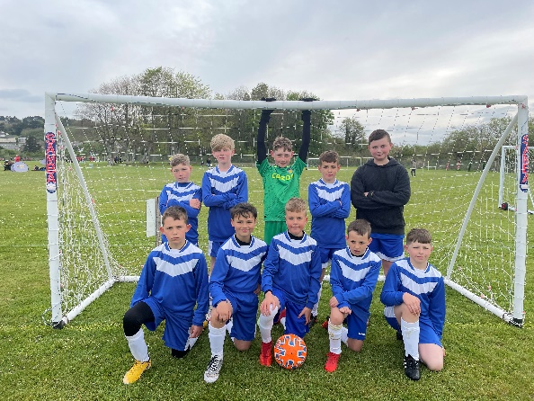
Congratulations to our boy’s football team who competed brilliantly in the Urdd Football 7 a side tournament in Blaendolau. It was a privilege to take a group of talented footballers to the competition. More importantly, the boys represented the school brilliantly and were polite to the opposition and officials. Da iawn bechgyn.

Extra-Curricular timetable

It has been great to see so many clubs being offered again in the school. We have had lunchtime and after school clubs for KS2 pupils this week and it has been fantastic to see so many children taking part in these. Thank you to all the staff for providing wonderful opportunities to our pupils. It looks like the children have had great fun. If you wish for your child to take part in the KS2 after school clubs, a timetable has been sent out via email and on our school Facebook page. Information for a sports club for younger pupils will be sent home this week. You can also speak to your child’s class teacher if you would like more information on this.

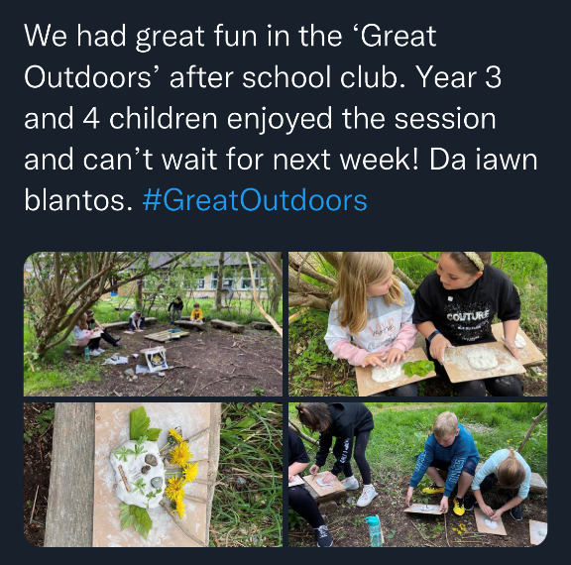
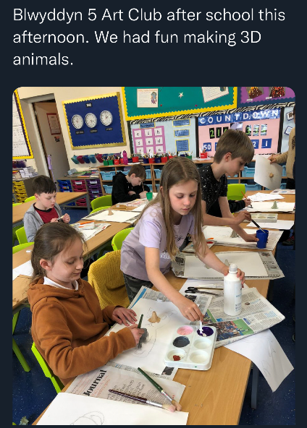

Mabolgampau / Sports Day

After a few years off, it is great to announce that this summer we will have our school sports day/mabolgampau. In order to ensure that we continue to plan safely and sensibly we have decided to organise our sports day over two days, similar to our Eisteddfod which was a big success. Please can you ensure that your child wears their house colours on the days below.

Tuesday, 14th June – Key Stage Two Sports Day
Wednesday, 15th June –Foundation Phase Sports Day

In the event of bad weather, we have planned for two back up days;

Thursday, 16th June – Back up day for Foundation Phase Sports Day
Friday, 17th June – Back up day for Key Stage Two Sports Day

The sports day will be held on the school field.

Llais o’r Llwyn

The Criw Cymraeg have created a short welsh newsletter which includes some language patterns, a competition and a ‘get to know a teacher’ featuring Mrs Maylor-Pridmore. This document is also attached in the email. We hope you enjoy!

Summer Holidays

The school will close on Friday, July 15th and reopen for all pupils on Monday 5th September 2022.

We look forward to sharing more information with you in the next newsletter.

Thank you for your continued support and cooperation,

Brian Evans

Head teacher

