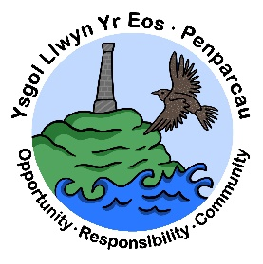 | CYNGOR SIR CEREDIGION COUNTY COUNCIL  Ysgol Gymunedol Llwyn yr Eos Community School  Penparcau  ABERYSTWYTH  Ceredigion  SY23 1SH
Prifathro/Headteacher  Mr Brian A L Evans | Ffôn/Phone 01970 617011  01970 625809  E-mail b.evans3@llwyn-yr-eos.ceredigion.sch.uk

Newsletter – July 2022

Dear Parents/Guardians,

It has been a very busy end to term. I am pleased to write that each and every class will have been on an end of term trip. This has been a highlight for us as a school and a welcome step forward as we continue to move forward from what has been a difficult and challenging few years. Remember, you can see more examples of what the children have been getting up to, by following us on our school twitter page @llwynyreos

Transition Day

On Friday 8th July, the children will be moving up to their next year group classes. The children will register as normal with their current class teachers and be released at home time by their current class teachers. Please find below and update and reminder of class teachers for each year group/class.

Meithrin/Nursery | Mrs Louise Flynn
Derbyn/Reception | To be confirmed next week
Blwyddyn 1/Year 1 | Mrs Lucy Davies
Blwyddyn 2/Year 2 | Mrs Donna Fitches
Blwyddyn 3/Year 3 | Mrs Anne Johnson/Mrs Catrin Arthur
Blwyddyn 4/Year 4 | Mr Steffan Davies
Blwyddyn 5/Year 5 | Mrs Leah Evans
Blwyddyn 6/Year 6 | Mrs Jane Thorogood
ALC 1/Dolphins | Mrs Kay Sandford/Mrs Jenny Mansfield
ALC 2 | Mrs Louise Maylor Pridmore
Pili Pala | Miss Laura Mayos
Enfys | Mr Nic Pugh

Extra-Curricular timetable

Thank you to all the staff who have volunteered to run extra-curricular activities to the children. It has been great to see so many children enjoying taking part in a variety of activities both during lunchtime and after school.
We will update you on a new extra-curricular timetable in September.

Mabolgampau / Sports Day

Sports day was a huge success! It was great to welcome parents from the juniors and infants for two separate sports days. We were very fortunate with the weather. It was excellent to see pupils participating in a range of events and competitions in the morning before competing in the running races and various other events in the afternoon. Thank you to you as parents and guardians for your role in making it a day/days to remember.

Another positive for us as a school was our first whole school assembly for quite some time. All pupils and staff from the school attended our sports day assembly where we were able to announce the winning team. We also gathered on the field to give a message to all of our friends in our community – SHWMAE!

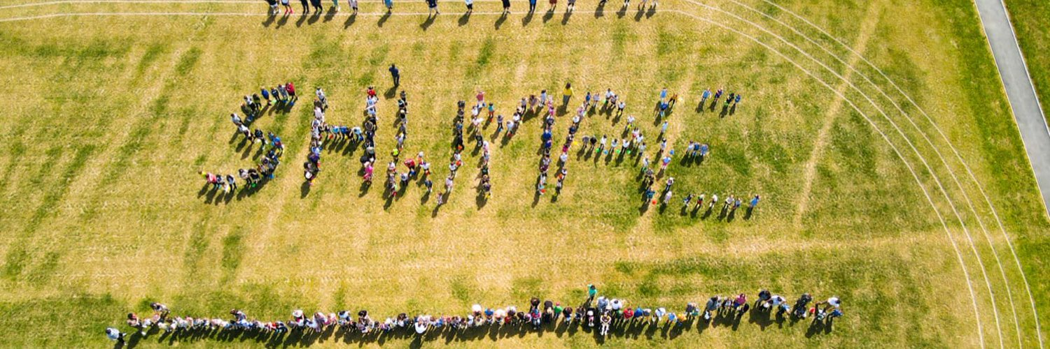

Congratulations to Hafod who were victorious this year!

Congratulations also to our Victor and Victrux Ludorum award winners from Year 6!

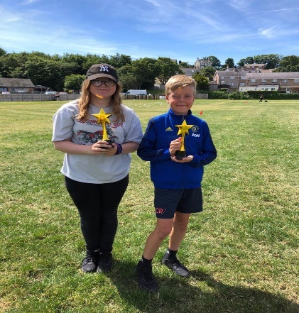
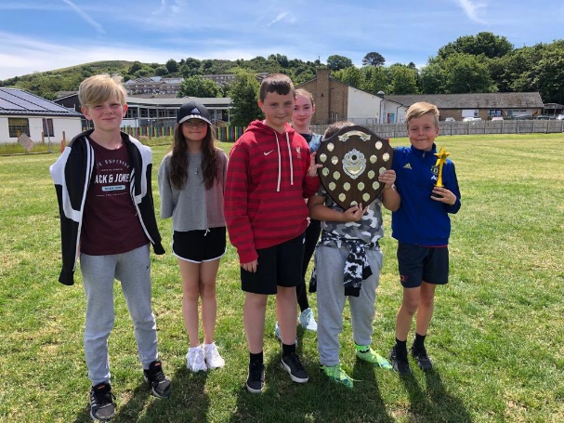
PTA
As we look forward to a new academic year, we would like to look at kick starting the role of the PTA (Parent Teacher Association) in order to provide more opportunities for fundraising and more importantly for us as a school to celebrate our success with you as parents and guardians through events.
We would like to work with you as parents to move the school forward to even greater success – your views and support are invaluable in ensuring this happens.
Thank you to those of you who contacted Mr Steffan Davies to declare your interest in joining and helping the school PTA. If you have not contacted Mr Steffan Davies and would like to join the PTA, you can of course do so.
We will meet on Tuesday 12th July after school in the junior’s hall. Please make your way to the main school reception and we will have a quick meeting at 3:30 to discuss the year as a whole and plan for the next academic year. All are welcome!

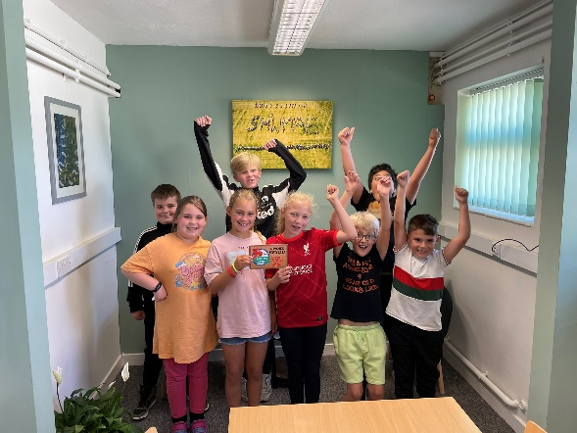
Cymraeg Campus – Bronze Award

Some good news to share… we were recently awarded with a bronze award for our outstanding progress in our welsh language provision and experiences. Well done to our Criw Cymraeg (pictured) who have coordinated much of the work that has gone on in the school. We will be going for our silver award next in the Autumn term.

Llais o’r Llwyn

The Criw Cymraeg will continue to send out Welsh newsletters as well as Welsh music that you can listen to at home. You may have heard music being played at various points during the morning or afternoon drop off and collection of your child/children. We will continue to send information and updates about what the Criw Cymraeg have been getting up to.

School Reports

School reports will be sent home with your child/children on Monday 11th July.

Summer Holidays

The school will close on Friday, July 15th and reopen for all pupils on Monday 5th September 2022.

We wish you all a happy and healthy summer holidays and look forward to welcoming you back to school in September.

Thank you for your continued support and cooperation,

Brian Evans

Head teacher

