|  |  |
| --- | --- |
|  | CYNGOR SIR CEREDIGION COUNTY COUNCIL  Ysgol Gymunedol Llwyn yr Eos Community School  Penparcau  ABERYSTWYTH  Ceredigion  SY23 1SH |
| Prifathro/Headteacher  Mr Brian Evans | Ffôn/Phone 01970 617011  01970 625809    E-mail: evansb56@hwbcymru.net |

Dear Parents/Guardians,

It has been a very busy few weeks here at Ysgol Llwyn yr Eos. We have been enjoying our ‘International Fortnight’ theme with plenty of opportunities to learn about countries from all over the world. We have also been completing some exciting tasks based on the Football World Cup.

One highlight was working with the beatboxer – ‘MR PHORMULA’. He worked with pupils in KS2 to create the rap/anthem – ‘Criw Caru Cymru’ You can listen by clicking on the link below. Enjoy!!

<https://www.j2e.com/ysgol-llwyn-yr-eos/Steffan+D/Criw+Caru+Cymru+.mp3/>

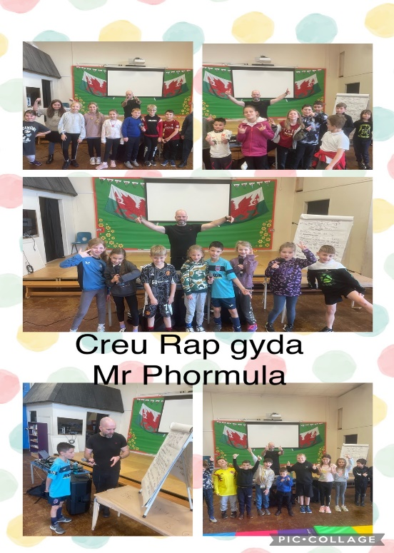

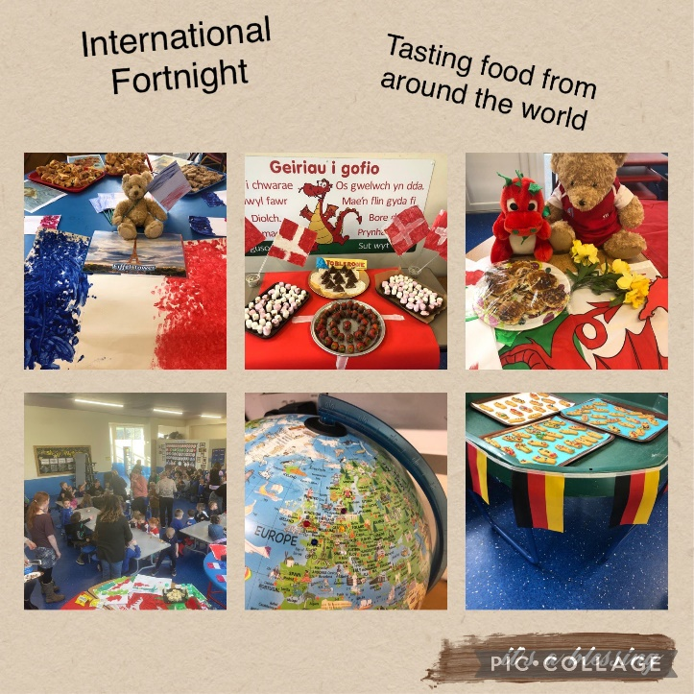

:**

Friday the 18th was a fantastic, fun filled day at the school. We raised **£173** towards this excellent cause and more importantly raised awareness about the charity. Thank you very much to you as parents and guardians for supporting us in doing this.

**Football Friday 25.11:**

This Friday, Wales will be playing against Iran at 10:00 AM. Pupils will be given the option to watch the game in school if they want. They are welcome to dress up in Welsh football kit or a football kit of their choice. They could also wear red, green, or white clothing to support the team for the game.

**Llwyn Yr Eos - School Christmas Dinner:**

This Year’s Christmas Dinner for all pupils will be on **Tuesday the 20th of** December 2022. Further information has been sent out on a paper letter to you and you will need to return a slip to your class teacher. The kitchen staff will need to know by the 9th of December if your child would like to receive a Christmas Dinner.

**Nativity/Christmas Service – 7.12.22:**

# **Infants and Resource Bases (Enfys, Pili Pala, Dolphins, Nursery, Reception, Years 1 &2)**

# These classes will perform in St Michael’s Church Aberystwyth at **1:30 PM on Wednesday 7th December.** Children will travel to St Michael’s Church on buses from school. Following the performance, you can pick your child up from the church. Alternatively, we will bring your child back to school on the buses and they can be collected from school as normal.

**Juniors (Years 3,4,5,6 & ALC 2)**

These classes will perform in St Michael’s Church Aberystwyth at 6:30PM on Wednesday 7th December. **We kindly ask you to bring the pupils to the church by no later than 6:10PM dressed ready for the performance.**

More information regarding clothing will be sent out by your class teacher.

**Purchasing tickets for Christmas Service:**

Tickets for the Christmas Service can be purchased from the **Junior Hall** from **8:30 – 9:00am every day beginning from Monday 28th November.** Tickets will be sold at **£1 per ticket** and **all proceeds will go to charity.**

**Christmas Fayre:**

A reminder that we will hold our Christmas Fayre at the school on **Tuesday 20th December at 3:00.** We are currently working with the Penparcau HUB in the hope of making this a truly community event. More information regarding this initiative will follow in the coming weeks.

**Christmas Holidays:**

**The school will close on Wednesday, 21st December and will reopen on Monday, 9th January.**

Thank you for your continued support and cooperation

**Brian Evans**

**Head teacher**