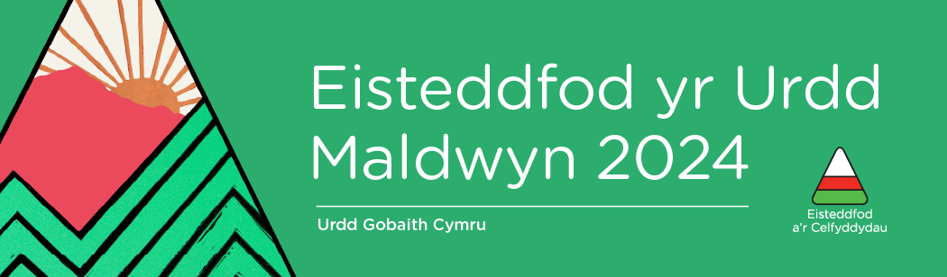

Eisteddfod yr Urdd Maldwyn 2024 tickets are now on sale!

Early Bird
Make the most of our Early Bird Prices and grab your tickets before the 19th of May!

Lower Income Tickets
We are happy to be able to offer free Maes Tickets to lower income families again this year. You can find more information on these tickets here.

Competition Timetable
Need to know which day to be on the Maes? Click here for the timetable!

Triban Festival
Triban Festival will return for the third time this year and will be held between the 30th of May and the 1st of June. The festival within a festival will open with a Machynlleth Comedy Festival Night on the Maes. To follow on Friday night the 31st of May Bwncath will headline, and to end the week in style there will be a PABO night with Eden on the 1st of June!

See you on the Maes!

