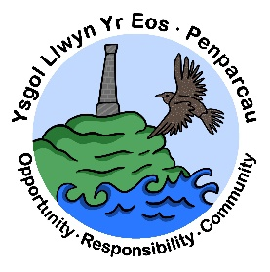 | CYNGOR SIR CEREDIGION COUNTY COUNCIL  Ysgol Gymunedol Llwyn yr Eos Community School  Penparcau  ABERYSTWYTH  Ceredigion  SY23 1SH
Prifathro/Headteacher  Mr Brian A L Evans | Ffôn/Phone 01970 617011  01970 625809

FREE SCHOOL MEALS

Dear Parents/Guardians,

As you know free school meals have been rolled out across Wales for all primary school pupils. This has been a fantastic initiative by the Welsh Government.

You may not know there are more ways to benefit from the Free School Meals initiative?
For example, there is the opportunity to receive the schools’ essentials grant.

A pupil may be able to get free meals if their parent or guardian (that is, the person who has care of the child) gets any of the following:
- Income Support
- Income-based Jobseeker’s Allowance
- Income-related Employment and Support Allowance
- Support under Part VI of the Immigration and Asylum Act 1999
- Guarantee element of Pension Credit
- Child Tax Credit (provided you’re not also entitled to Working Tax Credit and have an annual gross income of no more than £16,190)
- Working Tax Credit run-on - paid for 4 weeks after you stop qualifying for Working Tax Credit
- from 1 April 2019, Universal Credit - provided your household has an annualised net earned income¹ of no more than £7,400 (as assessed by earnings from up to three of your most recent assessment periods)
If your children receive Income-related Employment and Support Allowance, Income Support or Income-based Jobseeker’s Allowance in their own right, they could also be able to receive free school meals.
Please note that if you wish to receive the School Essentials Grant payment, you will still need to complete a Free School Meals Application Form. You should also let the school know directly if you wish for these child/ren to receive a free meal each day, or if they will be bringing a packed lunch.

The number of pupils signed up for this initiative impacts funding for the school so we would actively encourage to sign up if they are eligible.
Pop in to school to discuss this scheme if you would like to learn more about it.

HOW TO APPLY:

Free School Meals (ceredigion.gov.uk)

OR

Contact the Local Authority on 01545 570881 in order to complete an application over the telephone or visit one of our Customer Service Centres.

