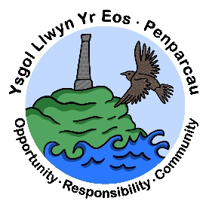 | CYNGOR SIR CEREDIGION COUNTY COUNCIL  Ysgol Gymunedol Llwyn yr Eos Community School  Penparcau  ABERYSTWYTH  Ceredigion  SY23 1SH
Prifathro/Headteacher  Mr Brian A L Evans | Ffôn/Phone 01970 617011  01970 625809

2/6/26
ESTYN INSPECTION 15th-17th of June.
Dear Parents/Guardians,
We would like to inform you that the school will be inspected by Estyn on Monday 15th June, Tuesday 16th June and Wednesday 17th June.
Inspectors will be visiting classrooms, speaking with staff and pupils, and reviewing the work of the school. This is an important opportunity to showcase the positive work taking place within our school community.
Below you will find a link or QR code which will take you to a parent/guardian questionnaire. We kindly ask that you complete the questionnaire so that ESTYN can gather your views on the school. This will need to be completed by Sunday, 7th June.
https://www.smartsurvey.co.uk/s/2CG3AS/

ESTYN have also arranged an opportunity for parents to share their views on Monday, 15th June at 3:30 after school in the Junior Hall.
Parents can bring their children to the Junior canteen where staff will be on hand to ensure that you can attend the meeting to share your views with ESTYN.
We appreciate your continued support and cooperation during this time.
Very best wishes
Brian Evans
Head teacher

