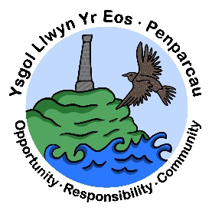 | CYNGOR SIR CEREDIGION COUNTY COUNCIL  Ysgol Gymunedol Llwyn yr Eos Community School  Penparcau  ABERYSTWYTH  Ceredigion  SY23 1SH
Prifathro/Headteacher  Mr Brian A L Evans | Ffôn/Phone 01970 617011  01970 625809

Dear Parents/Guardians,
Our Core Values:

- OPPORTUNITY
- RESPONSIBILITY
- COMMUNITY

At our school, we are committed to fostering a supportive and inclusive environment grounded in our core values of Opportunity, Responsibility and Community.

These core values are an integral part of our school and the experiences we offer.
School Development Plan:

A reminder of our three focused strategic priorities for improving standards of teaching and learning. They are as follows:

- Further develop opportunities for pupils to progress their creative and extended writing skills
- To continue to develop Welsh language oracy skills across the school and implement Welsh medium Reception class from September 2025
- To develop pupils’ retrieval/fluency practice to improve retention of mathematical learning.

